***Creating Microservices for account and loan***

Used dependencies

- Spring Boot DevTools

- Spring Web

On port: 8080

Method: GET

Endpoint: /accounts/{number}

AccountController.java

package com.example.account;

import org.springframework.web.bind.annotation.*;

import java.util.Map;

import java.util.HashMap;

*@RestController*

*@RequestMapping*("/accounts")

public class AccountController {

*@GetMapping*("/{number}")

public Map<String, Object> getAccount(*@PathVariable* String number) {

Map<String, Object> response = new HashMap<>();

response.put("number", number);

response.put("type", "savings");

response.put("balance", 234343);

return response;

}

}

LoanApplication.java

package com.example.account;

import org.springframework.boot.SpringApplication;

import org.springframework.boot.autoconfigure.SpringBootApplication;

*@SpringBootApplication*

public class AccountApplication {

public static void main(String[] args) {

SpringApplication.*run*(AccountApplication.class, args);

}

}

Output:  
  
url:<http://localhost:8080/accounts/1452>

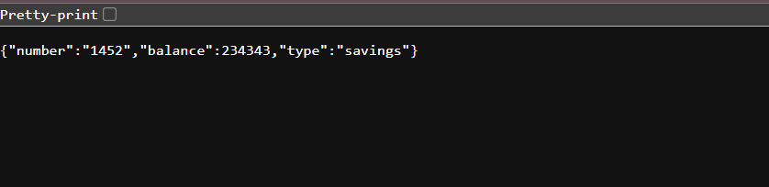

url:<http://localhost:8080/accounts/1453>

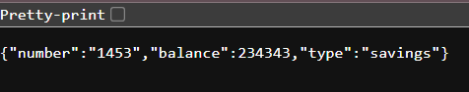

**Loan Microservice**

o Method: GET

Endpoint: /loans/{number}

loansController.java

package com.example.loan;

import org.springframework.web.bind.annotation.*;

import java.util.Map;

import java.util.HashMap;

*@RestController*

*@RequestMapping*("/loans")

public class LoanController {

*@GetMapping*("/{number}")

public Map<String, Object> getLoan(*@PathVariable* String number) {

Map<String, Object> response = new HashMap<>();

response.put("number", number);

response.put("type", "car");

response.put("loan", 400000);

response.put("emi", 3258);

response.put("tenure", 18);

return response;

}

}

LoanApplication.java

package com.example.loan;

import org.springframework.boot.SpringApplication;

import org.springframework.boot.autoconfigure.SpringBootApplication;

*@SpringBootApplication*

public class LoanApplication {

public static void main(String[] args) {

SpringApplication.*run*(LoanApplication.class, args);

}

}

output

url:<http://localhost:8081/loans/1452>

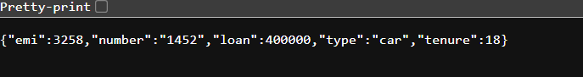

url:[http://localhost:8081/loans/145](http://localhost:8081/loans/1453)3